**Software Requirements Specification**

**Automated Flood Warning and Relief**

**System**

**Date of Submission: 03/02/2025**

# Table of Contents

### Table of Contents .......................................................................................................... ii Revision History ........................................................................................................... iii 1. Introduction .............................................................................................................. 1

1.1 Purpose ............................................................................................................................. 1

1.2 Document Conventions ..................................................................................................... 1

1.3 Intended Audience and Reading Suggestions .................................................................. 1

1.4 Project Scope .................................................................................................................... 1

1.5 References ........................................................................................................................ 2

### 2. Overall Description .................................................................................................. 2

2.1 Product Perspective .......................................................................................................... 2

2.2 Product Features ............................................................................................................... 2

2.3 User Classes and Characteristics ..................................................................................... 2

2.4 Operating Environment ..................................................................................................... 3

2.5 Design and Implementation Constraints ........................................................................... 3

2.6 User Documentation ......................................................................................................... 3

2.7 Assumptions and Dependencies ....................................................................................... 3

### 3. System Features ...................................................................................................... 4

3.1 System Feature 1 .............................................................................................................. 4

3.2 System Feature 2 (and so on) ........................................................................................... 4

### 4. External Interface Requirements ............................................................................ 6

4.1 User Interfaces .................................................................................................................. 6

4.2 Hardware Interfaces .......................................................................................................... 7

4.3 Software Interfaces ........................................................................................................... 7

4.4 Communications Interfaces ............................................................................................... 8

### 5. Other Nonfunctional Requirements ....................................................................... 8

5.1 Performance Requirements .............................................................................................. 8

5.2 Safety Requirements ......................................................................................................... 9

5.3 Security Requirements ...................................................................................................... 9

5.4 Software Quality Attributes ................................................................................................ 9

***Software Requirements Specification for <Project> Page iii***

**6. Other Requirements ................................................................................................ 9 Appendix A: Glossary ................................................................................................... 9 Appendix B: Analysis Models .................................................................................... 10 Appendix C: Issues List .............................................................................................. 10**

# Revision History

|  |  |  |  |
| --- | --- | --- | --- |
| **Name** | **Date** | **Reason For Changes** | **Version** |
| AL Fahim | 03/02/2024 | Revised system features and descriptions | 1.0 |
|  |  |  |  |

# 1. Introduction

## 1.1 Purpose

The automated Flood Warning and Relief System project aims to address the adverse effects of floods with more advanced systems for real-time flood forecasting, alert notification, and relief coordination. The system is jointly developed with the Bangladesh Water Development Board and the Ministry of Disaster Management and Relief. It combines real-time monitoring data collection, water level measurement, AI-based predictions, alerts and managers of protection and relief operations.

## 1.2 Document Conventions

Bold Text: Section headings and key terms.

Monospaced Text: Code snippets or system commands.

## 1.3 Intended Audience and Reading Suggestions

This document is intended for:

* Software Developers: For system implementation.
* Project Managers: To oversee execution.
* Disaster Management Authorities: For alignment with disaster preparedness policies.
* End Users (General Public & Officials): To understand system functionalities.

## 1.4 Project Scope

The integration of the system enables tracking and coordination of emergency responses and citizen reporting, alongside real-time flood and disaster warning and monitoring. It is intended for voluntary and professional responders, the disaster management department, aid agencies, and BWDB for presenting public emergency management meeting basic timelines.

## 1.5 References

* Deltares. "Mobile Services for Flood Early Warning in Bangladesh." Available at: Deltares
* World Bank. "$500 Million World Bank Financing to Help Bangladesh Improve Disaster Preparedness for Floods." Available at: World Bank
* Flood Forecasting and Warning Center (FFWC), Bangladesh Water Development Board (BWDB). "Flash Flood Early Warning System." Available at: FFWC

# 2. Overall Description

### 2.1 Product Overview

The system was made as an addition to the current flood management strategies in

Bangladesh. The goal is to expand the capabilities of agencies such as the BWDB and FFWC to strengthen their disaster prediction and response mechanisms through messaging and communication systems that improve the flow of relief and response coordination.

## 2.2 Product Features

* Flood Prediction and Alerts – Uses AI-based forecasting to issue flood warnings.
* Shelter Monitoring – Provides real-time shelter availability.
* Relief Distribution Tracking – Ensures transparency in aid allocation.
* Emergency Reporting and Communication – Enables two-way interaction between citizens and response teams.
* User Registration – Offers location-based, personalized alerts.

## 2.3 User Classes and Characteristics

* General Public: Receives flood alerts and emergency information.
* Disaster Management Authorities: Manages response strategies and coordinates relief.
* Relief Organizations: Ensures efficient distribution of aid supplies.
* BWDB Officials: Oversees flood prediction models and emergency management.

## 2.4 Operating Environment

* Mobile Application: Available for Android/iOS.
* Web-Based Dashboard: For disaster response authorities.
* Backend Servers: Hosted on secure cloud infrastructure.

## 2.5 Design and Implementation Constraints

* Real-time Processing: Must handle large-scale data analytics efficiently.
* Reliability: Ensures 99.9% system uptime.
* Scalability: Supports peak usage during disasters.

## 2.6 User Documentation

* User manuals and troubleshooting guides.
* Online FAQs and tutorial videos.

## 2.7 Assumptions and Dependencies

* Assumption: Availability of reliable meteorological data.
* Dependency: Collaboration with telecom providers for SMS alerting.

# 3. System Features

### 3.1 Flood Prediction and Alerts

#### 3.1.1 Description and Priority

The system utilizes AI-driven predictive models and real-time sensor data to forecast floods and issue alerts. Priority: High

#### 3.1.2 Functional Requirements

REQ-1: The system shall collect and analyze water level data from BWDB sensors.

REQ-2: The system shall issue flood warnings via SMS, push notifications, and sirens.

REQ-3: Alerts should be geo-targeted based on real-time risk zones.

#### 3.1.3 Business Rules

* Alerts must be disseminated at least 24 hours before a predicted flood.
* Data collection must comply with national meteorological standards.

### 3.2 Shelter Monitoring

**3.2.1 Description and Priority**

The system provides real-time updates on shelter locations and capacities. Priority: High

#### 3.2.2 Functional Requirements

REQ-1: Users should be able to locate the nearest shelters based on GPS.

REQ-2: Shelter managers should update occupancy levels in real time.

**3.2.3 Business Rules**

• Shelter data should be verified by local authorities.

### 3.3 Relief Distribution Tracking

**3.3.1 Description and Priority**

Monitors the allocation and distribution of relief materials. Priority: High

#### 3.3.2 Functional Requirements

REQ-1: Aid inventory must be updated with each dispatch.

REQ-2: Users and authorities should be able to track relief deliveries.

**3.3.3 Business Rules**

• Relief distribution records must be maintained for auditing.

### 3.4 Emergency Reporting and Communication

**3.4.1 Description and Priority**

Allows citizens to report emergencies and receive assistance. Priority: Medium

#### 3.4.2 Functional Requirements

REQ-1: The system must allow users to submit emergency reports.

REQ-2: Emergency response teams should receive notifications instantly.

**3.4.3 Business Rules**

• Reports must be acknowledged within 30 minutes.

### 3.5 User Registration

**3.5.1 Description and Priority**

Enables users to receive personalized flood alerts. Priority: Medium

#### 3.5.2 Functional Requirements

REQ-1: Users must register using verified phone numbers.

REQ-2: Registered users should receive alerts relevant to their location.

**3.5.3 Business Rules**

• Only government-verified numbers can be used for official communications.

# 4. External Interface Requirements

## 4.1 User Interfaces

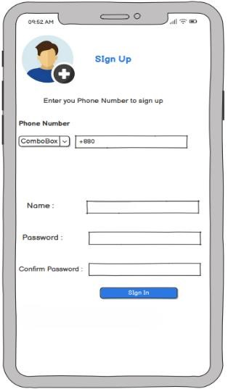 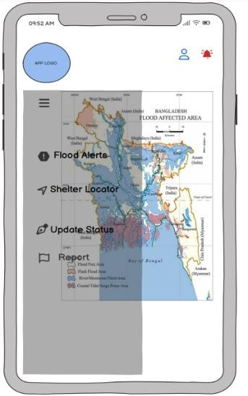 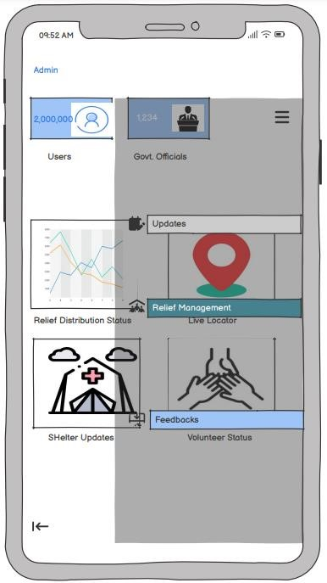

Registration Page Citizen Dashboard Admin Dashboard

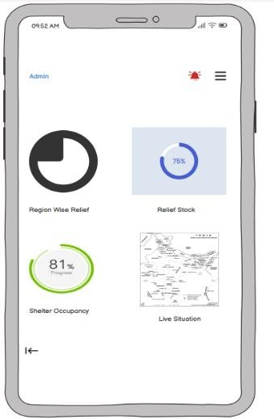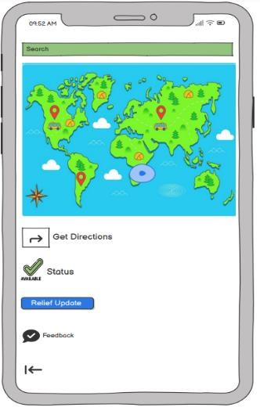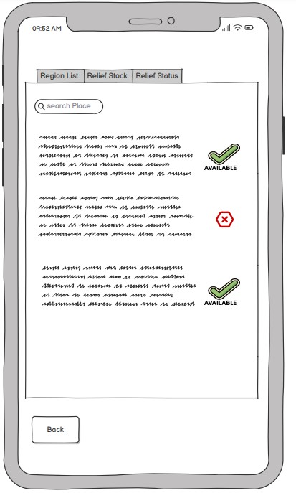

Admin Management Relief & Shelter Locator Region Overview

## 4.2 Hardware Interfaces

* IoT Sensors: Water level monitoring.
* Mobile Devices: Citizen and field worker accessibility.
* GPS tracking for monitoring relief distribution vehicles.

#### System Architecture Diagram

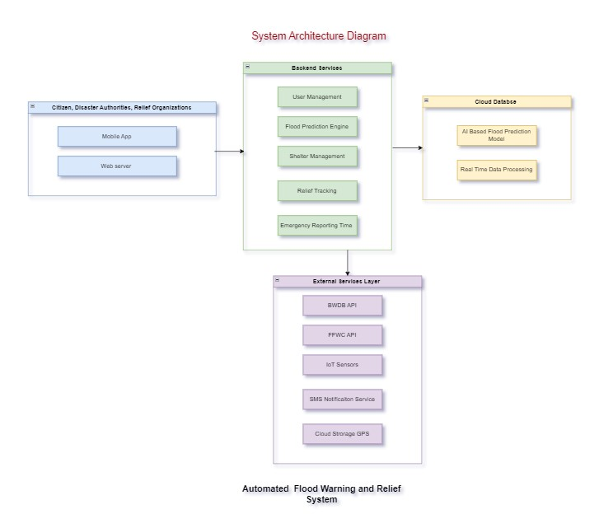

## 4.3 Software Interfaces

• API Integrations: FFWC, BWDB flood monitoring systems.

## 4.4 Communications Interfaces

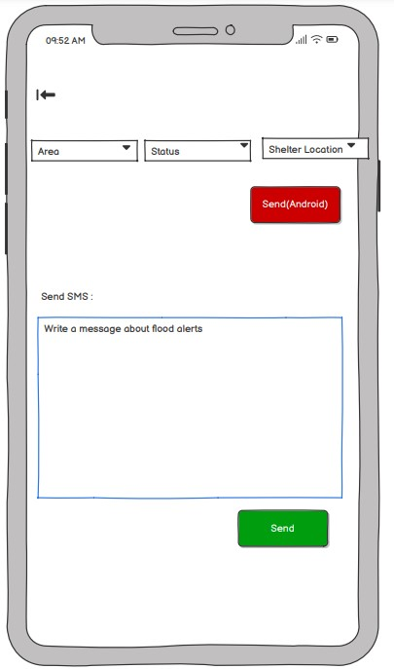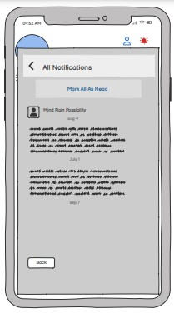

Alert Panel Citizen notification

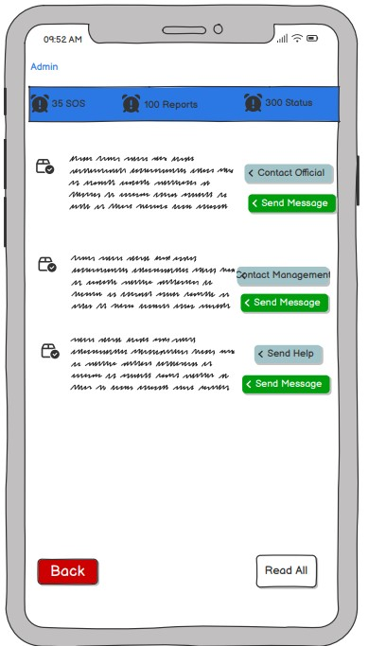 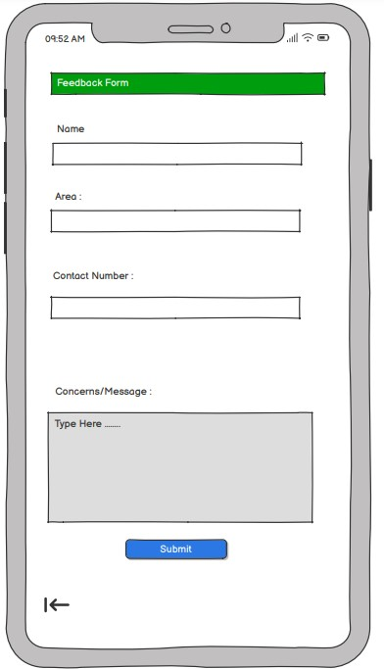

Admin Communication Panel Citizen Communication Panel

# 5. Other Nonfunctional Requirements

## 5.1 Performance Requirements

* Processes real-time flood data within 5 seconds.
* Supports low-bandwidth users in rural areas.

## 5.2 Safety Requirements

* Ensures that flood alerts reach at least 95% of affected populations.
* Must have an emergency power backup to keep systems operational during disasters.

## 5.3 Security Requirements

* Implements end-to-end encryption for all communications.
* Must follow Bangladesh National Cyber Security Guidelines to protect sensitive user data.

## 5.4 Software Quality Attributes

* Usability: Simple and intuitive UI.
* Reliability: 99.9% uptime guarantee.
* Interoperability: Integrates with governmental emergency response systems.
* Maintainability: Supports modular updates without downtime.

**6. Other Requirements**

* The system must support Bangla and English for accessibility.
* The platform must be able to handle increased user traffic during disaster situations.

**Appendix A: Glossary**

* BWDB: Bangladesh Water Development Board.
* FFWC: Flood Forecasting and Warning Center.
* IoT: Internet of Things.
* API: Application Programming Interface.
* GPS: Global Positioning System

***Page***

**Appendix B: Analysis Models**

**Use Case Diagram:**

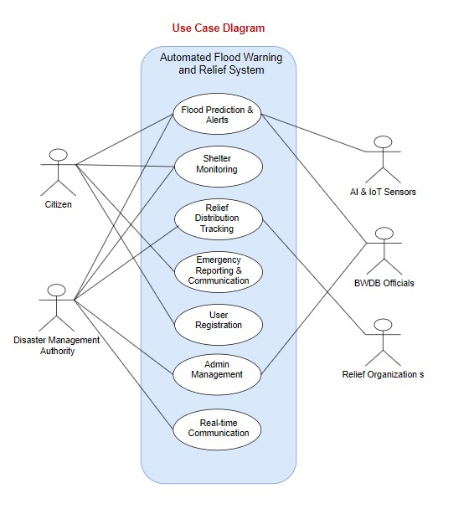

**Appendix C: Issues List**

* Pending validation with disaster management authorities.
* Integration testing with national agencies is required.
* Mobile network reliability concerns need further testing.